New and Notable Juvenile Fiction 2019

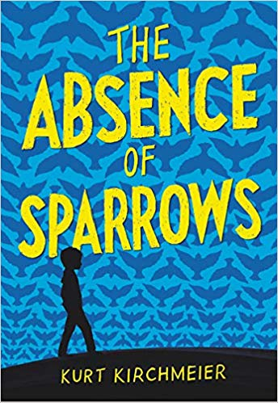

The Absence of Sparrows
Kurt Kirchmeier, author.
9780316450928
In the small town of Griever's Mill, eleven-year-old Ben Cameron is expecting to finish off his summer of relaxing and bird-watching without a hitch. But everything goes wrong when, at random, people are turned into frozen versions of themselves. There's nowhere to run, nowhere to hide, and no one knows how to stop it. With his mom on the verge of a breakdown, and his brother intent on following the dubious plans put forth by a nameless voice on the radio, Ben must hold out hope that his town's missing sparrows will return with everyone's souls before the glass plague takes them away forever.

All the Greys on Greene Street
Laura Tucker, author.
9780451479532
SoHo, 1981. Twelve-year-old Olympia is an artist - and in her neighborhood, that's normal. Her dad brings antique paintings back to life, while her mother makes intricate sculptures in a corner of their loft, leaving Ollie to roam the streets of New York with her best friends, drawing everything that catches her eye. Then everything falls apart. Ollie's dad disappears in the middle of the night, leaving her only a cryptic note. Her mom has gone to bed, and she's not getting up. And someone keeps calling, looking for a missing piece of art. Olympia knows her dad is the key - but first, she has to find him, and time is running out.

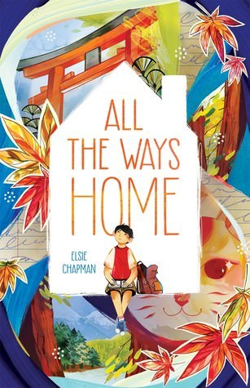

All the Ways Home
Elsie Chapman, author.
9781250166791
After losing his mom in a fatal car crash, Kaede developed anger issues and spent his last year of middle school acting out. Critically in danger repeating the seventh grade, Kaede is given a summer assignment: write an essay about what home means to him. It’s tougher now that he's on his way to Japan to reconnect with his estranged father and older half-brother, but if there's a chance Kaede can build a new family from an old one, he's willing to try. But building new relationships isn’t as easy as destroying old ones, and one last desperate act will change the way Kaede sees everyone - including himself.
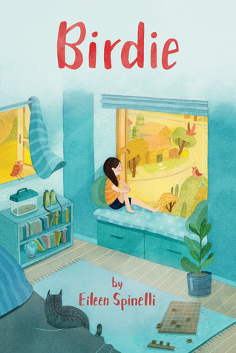

Birdie
Eileen Spinelli, author.
9780802855138
Twelve-year-old Birdie Briggs loves birds. They bring her comfort when she thinks about her dad, a firefighter who was killed in the line of duty. Life without her dad isn’t easy, but at least Birdie still has Mom and Maymee, and her friends Nina and Martin. But then Maymee gets a boyfriend, Nina and Martin start dating, and Birdie’s mom starts seeing a police officer. And suddenly not even her beloved birds can lift Birdie’s spirits. Her world is changing, and Birdie wishes things would go back to how they were before. But maybe change, painful as it is, can be beautiful too. A novel in verse.

Caterpillar Summer
Gillian McDunn, author.
9781681197432
Cat and her brother Chicken have always had a very special bond. When he has a "meltdown," she's the one who knows what Chicken needs. Since her mom works double-hard since her father passed away, Cat has been the glue holding her family together. But even the strongest glue sometimes struggles to hold. When Cat and Chicken end up spending three weeks with grandparents they never knew, for the first time in years, Cat has the opportunity to be a kid again, and learns that even the most broken or strained relationships can be healed if people take the time to walk in one another's shoes.

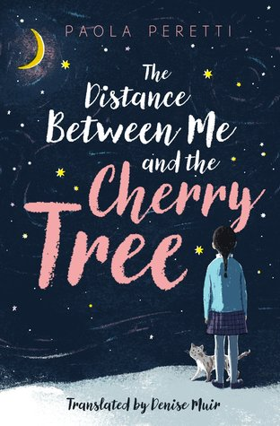

The Distance Between Me and the Cherry Tree
Paola Peretti, author.
9781534439627
There are a lot of things ten-year-old Mafalda cares a lot about: Counting the stars in the night sky, playing soccer, and climbing the cherry tree outside her school. But soon she won’t be able to do them anymore - because she’s going blind. The last thing she wants is for people to treat her differently, so she hides the fact that her vision is deteriorating, and she makes a plan: When the time is right, she’ll go live in the cherry tree, just like her favorite book character. But as Mafalda loses her sight, surprising things come in to focus. With the help of her family and friends, Mafalda discovers the things that matter most.

A Drop of Hope
Calabrese, Keith, author.
9781338233209
Times are tough. Jobs are scarce and miracles are in short supply. But in Cliffs Donnelly, Ohio, an old well has suddenly, impossibly, begun to grant wishes. And three sixth graders are the only ones who know why. Ernest Wilmette believes a good deed makes magic happen. Ryan Hardy thinks they should just mind their own business. Lizzy MacComber believes in facts, not fairy tales. As more wishes are made, the well's true secret gets harder and harder to keep. Ernest, Ryan, and Lizzy know they can't fix the world. But in their own little corner of it, they can give everyone a little hope... one wish at a time.

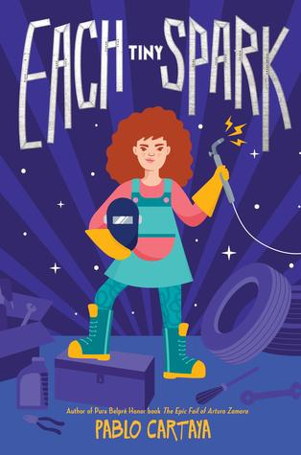

Each Tiny Spark
Pablo Cartaya, author.
9780451479723
Emilia Torres has a wandering mind, but she remembers what matters: A time when her family was whole. When Dad returns from deployment, Emilia expects that her life will get back to normal. Instead, Dad shuts himself in the back stall of their family's auto shop to work on an old car. Emilia peeks in on him daily, until one day, Dad calls Emilia over and begins teaching her how to weld. Over time, flickers of her old dad reappear. But as Emilia finds a way to repair the relationship with her father at home, her community ruptures, with some of her classmates, including her best friend, at the center of the conflict.

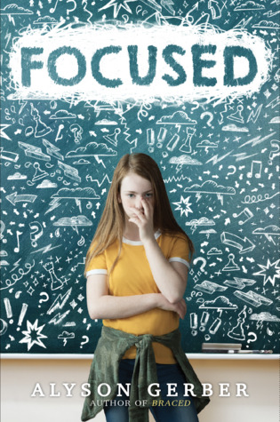

Focused
Alyson Gerber, author.
9781338185973
Twelve-year-old Clea wants to do her homework, follow instructions, pay attention in school, and play chess on the school team... but how can she focus when the people around her are always chewing gum loudly or making other annoying noises? It's starting to be a problem, and not just in school - other kids are starting to notice. When she learns she has ADHD, she knows life can't continue the way it's been going. She's just not sure how you can fix a problem that's all in your head. But with help from the psychiatrist who seems to really understand her, she is determined to learn how to focus.
Girl of the Southern Sea
Michelle Kadarusman, author.
9781772780819
From the time she was a little girl, Nia has dreamed up adventures about the Javanese mythical princess, Dewi Kadita. Now fourteen, and living in the Jakarta slums, Nia would love nothing more than to continue her education and become a writer. But high school is expensive. After she survives a minibus accident unharmed and the locals say she is blessed with 'good luck magic,' Nia sees an opportunity to raise money. But when the crowd turns against her and she discovers her father's plan to marry her off to an older man, she must summon courage and conviction to write her own story.

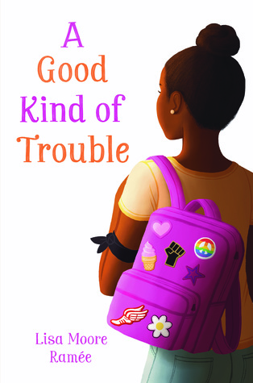

A Good Kind of Trouble
Lisa Moore Ramée, author.
9780062836687
Twelve-year-old Shayla is allergic to trouble. All she wants to do is to follow the rules. But in junior high, it’s like all the rules have changed. Shay’s sister, Hana, is involved in Black Lives Matter, but Shay doesn't think that's for her. After experiencing a powerful protest, though, Shay starts wearing an armband to school in support of the Black Lives movement. Soon everyone is taking sides. And she is given an ultimatum. Shay is scared to do the wrong thing (and even more scared to do the right thing), but if she doesn't face her fear, she'll be forever tripping over the next hurdle. Now that’s trouble, for real.

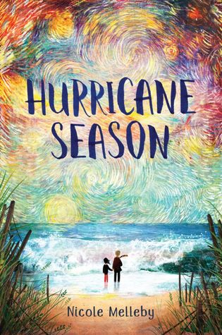

Hurricane Season
Nicole Melleby, author.
9781616209063
Hoping to better understand her father - who sometimes looks for music in the middle of storms, and for whom hurricane months bring unpredictable good and bad days - Fig takes an art class to experience life as an artist does. Then her dad shows up at school, confused and looking for her, bringing social services to their door. Fig is sure it’s up to her alone to solve her father’s problems and protect her family’s privacy. But with the help of her best friend, a cute girl at the library, and a surprisingly kind new neighbor, Fig learns she isn’t as alone as she once thought... and begins to compose her own definition of family.

Lalani of the Distant Sea
Erin Entrada Kelly, author.
9780062747273
Life is difficult on the island of Sanlagita. To the west looms a vengeful mountain. To the north, a dangerous fog swallows sailors who dare to venture out. And what does the future hold for young girls? Chores and more chores. When Lalani’s mother falls gravely ill, she faces an impossible task: She must leave Sanlagita and find the riches of the legendary Mount Isa, which towers on an island to the north. But generations of men and boys have died on the same quest - how can an ordinary girl survive the epic tests of the archipelago? And how will she manage without Veyda, her best friend?

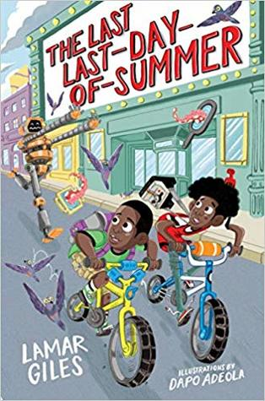

The Last Last-Day-of-Summer
Lamar Giles, author, and Dapo Adeola, illustrator.
9781328460837
Otto and Sheed are the local sleuths in their zany Virginia town, masters of unraveling mischief using their unmatched powers of deduction. And as the summer winds down and the first day of school looms, the boys are craving just a little bit more time for fun, even as they bicker over what kind of fun they want to have. That is, until a mysterious man appears with a camera that literally freezes time. Now, with the help of some very strange people and even stranger creatures, Otto and Sheed will have to put aside their differences to save their town—and each other—before time stops for good.

Lizzie Flying Solo
Nanci Turner Steveson, author.
9780062673183
Lizzie St. Claire wants to be invisible. Forced to move out of her home, she and her mom now live in a transitional housing shelter, Good Hope, until they can get back on their feet. Lizzie just wants to keep her head down at Good Hope and her new school, so she doesn’t have to admit the real reason she and her mom lost everything. But when Lizzie finds herself at the nearby Birchwood Stables, some new friends—along with the arrival of a frightened pony named Fire—help Lizzie to open up and accept help from those around her, even if it means she’ll have more to lose if things change again.
Max & the Midknights
Lincoln Peirce, author.
9781101931080
Max wants to be a knight! Too bad that dream is about as likely as finding a friendly dragon. But when Max's uncle Budrick is kidnapped by the cruel King Gastley, Max has to act...and fast! Joined by a band of brave adventurers--the Midknights--Max sets out on a thrilling quest: to save Uncle Budrick and restore the realm of Byjovia to its former high spirits! Magic and (mis)adventures abound in this hilarious illustrated novel from the New York Times bestselling creator of the Big Nate series, Lincoln Peirce. And for extra fun, check out the audiobook version, too!

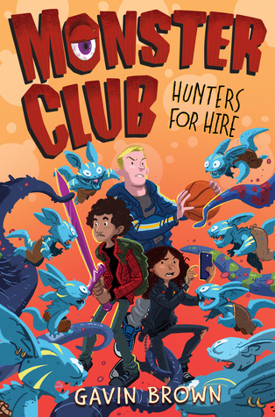

Monster Club: Hunters for Hire
Gavin Brown, author.
9781338318517
In a world where monsters roam, someone has to keep these creatures in check, right? Luckily, this is the iPhone era. When Tommy, Spike, and Karim become registered "Independent Adventure Contractors" for a brand-new app, AppVenture ("It's like Uber for monster-slaying!"), they couldn't be more thrilled. But soon the trio stumbles upon a secret: AppVenture has been releasing monsters into the wild in order to generate more business. Now the three friends find themselves on the run from a venture-backed startup that will do anything to make sure our heroes don't live to reveal the truth.

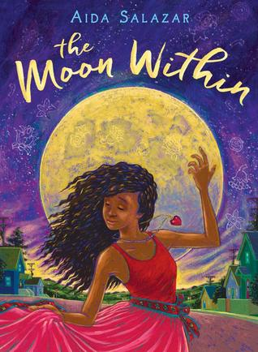

The Moon Within
Aida Salazar, author.
9781338283372
Eleven-year-old (nearly twelve) Celi Rivera, who is a mix of Black-Puerto Rican-Mexican Indian, has a life which swirls with questions. About her changing body. Her first attraction to a boy. And her best friend's exploration of what it means to be genderfluid. But most of all, about her mother's insistence that she have a moon ceremony when her first period arrives. It's an ancestral Mexica ritual that Mima and her community have reclaimed, but Celi promises she will NOT be participating. In this novel in verse, can Celi find the power within herself to take a stand for who she wants to be?
Nikki on the Line
Barbara Carroll Robert, author.
9780316521901
Thirteen-year-old Nikki Doyle's dreams of becoming a basketball great feel within reach when she's selected to play on an elite-level club team. But in a league with taller, stronger, and faster girls, Nikki suddenly isn't the best point guard. In fact, she's no longer a point guard at all, which leaves her struggling to figure out who she is and how she fits in. As the stakes rise on the basketball court, at school, and at home, Nikki's confidence plummets. Can she learn to compete at this new, higher level? And how hard is she willing to work to find out?

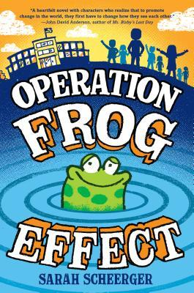

Operation Frog Effect
Sarah Scheerger, author.
9780525644125
Hi-- It's us, Ms. Graham's class. We didn't mean to mess things up. But we did. We took things too far, and now Ms. Graham is in trouble--for something we did. We made a mistake. The question is, can we fix it? Ms. Graham taught us that we get to choose the kind of people we want to be and that a single act can create ripples. So get ready, world--we're about to make some ripples.
Told in eight perspectives, Operation Frog Effect tells the unforgettable story of how eight very different kids take responsibility for their actions and unite for a cause they all believe in.

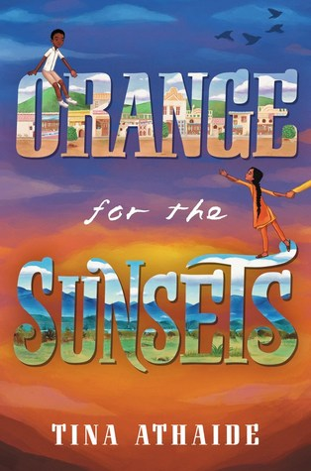

Orange for the Sunsets
Tina Athaide, author.
9780062795298
Asha and her best friend, Yesofu, never cared about the differences between them: Indian. African. Girl. Boy. Short. Tall. But when Idi Amin announces that Indians have ninety days to leave the country, suddenly those differences are the only things that people in Entebbe can see.Determined for her life to stay the same, Asha clings to her world tighter than ever before. But Yesofu is torn, pulled between his friends, his family, and a promise of a better future. Now as neighbors leave and soldiers line the streets, the two friends find that nothing seems sure—not even their friendship.

Pavi Sharma's Guide to Going Home
Bridget Farr, author.
9780316491068
After being bounced around between foster families and shelter stays, twelve-year-old Pavi is a foster care expert, and she runs a "business" teaching other foster kids all she has learned. With a wonderful foster family in mom Marjorie and brother Hamilton, things are looking up for Pavi. Then Pavi meets Meridee: a new five-year-old foster kid, who is getting placed at Pavi's first horrendous foster home. Pavi knows no one will trust a kid about what happened on Lovely Lane, even one as mature as she is, so it's up to her to save Meridee.

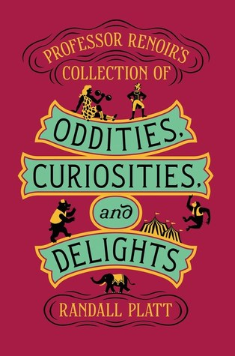

Professor Renoir's Collection of Oddities, Curiosities, and Delights
Randall Beth Platt, author.
9780062643346
By her fourteenth birthday, Babe Killingsworth measures 6ʹ9ʺ and weighs 342 pounds. In 1896, what other options does a giant have but to join a carnival? Professor Renoir’s Collection of Oddities, Curiosities, and Delights, opens the doorway to exploitation and neglect. But Babe’s love for Euclid (a chimp) and Jupiter (a bear) keeps her anchored. Enter Carlotta Jones, billed as the world’s smallest girl, whose elephant act leaves much to be desired. How can a giant like Babe and a dwarf like Carlotta ever see eye to eye? They don’t at first, but soon they understand that a common enemy can bring anyone together.

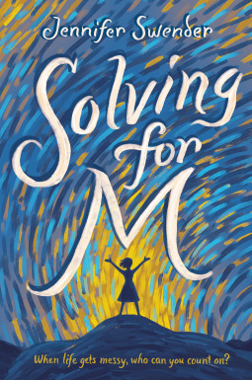

Solving for M
Jennifer Swender, author.
9781101932902
When Mika starts fifth grade at the middle school, her neat life gets messy. Separated from old friends and starting new classes, Mika is far from her comfort zone. And math class is the most confusing of all, especially when her teacher Mr. Vann assigns math journals. Art in math? Who's ever heard of such a thing? But when challenges arise at home, Mika realizes there are no easy answers. Maybe, with some help from friends, family, and one unique teacher, a math journal can help her work out problems, and not just the math ones.

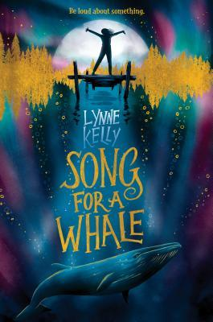

Song for a Whale
Kelly Lynne, author.
9781524770235
From fixing the class computer to repairing old radios, twelve-year-old Iris is a tech genius. But she's the only deaf person in her school, so people often treat her like she's not very smart. If you've ever felt like no one was listening to you, then you know how hard that can be. When she learns about Blue 55, a real whale who is unable to speak to other whales, Iris understands how he must feel. Then she has an idea: she should invent a way to "sing" to him! But he's three thousand miles away. How will she play her song for him?

Stand on the Sky
Erin Bow, author.
9781328557469
It goes against all tradition for Aisulu to train an eagle, for among the Kazakh nomads, only men can fly them. But everything changes when Aisulu discovers that her brother, Serik, has been concealing a bad limp that risks not just his future as the family's leader, but his life too. To save her brother and keep her family from having to leave their nomadic life behind forever, Aisulu must earn her eagle’s trust and fight for her right to soar. Along the way, she discovers that family are people who choose each other, home is a place you build, and hope is a thing with feathers.

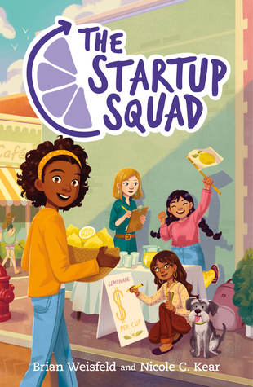

The Startup Squad
Brian Weisfeld, author.
9781250180414
All the great leaders had to start somewhere. And Resa is starting with the lemonade stand competition her teacher assigned to the class. The prize: line-skipping tickets to Adventure Central. The competition: Val, Resa's middle school nemesis. And the biggest obstacle to success: Resa's own teammates. Harriet is the class clown, Amelia is the new girl who thinks she knows best, and Didi is Resa's steadfast friend - who doesn't know the first thing about making or selling lemonade. The four of them quickly realize that the recipe for success is tough to perfect - but listening to each other is the first step.

To Night Owl from Dogfish
Holly Goldberg Sloan and Meg Wolitzer, authors.
9780525553236
The only things Avery Bloom and Bett Devlin have in common is that they are both twelve years old, and are both being raised by single, gay dads. When their dads fall in love, Bett and Avery are sent, against their will, to the same sleepaway camp, where their dads hope that they will find common ground. But things soon go off the rails for the girls (and for their dads too), and they find themselves on a summer adventure that neither of them could have predicted. Now that they can't imagine life without each other, will the two girls (who sometimes call themselves Night Owl and Dogfish) figure out a way to be a family?

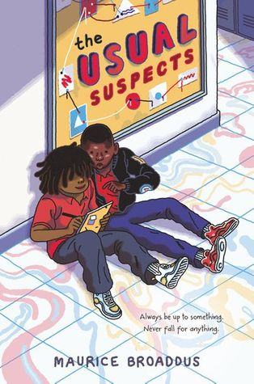

The Usual Suspects
Maurice Broaddus, author.
9780062796318
Thelonius Mitchell is tired of being labeled. He’s in special ed, separated from the “normal” kids at school who don’t have any “issues.” That’s enough to make all the teachers and students look at him and his friends with a constant side-eye - although his disruptive antics and pranks have given him a rep, too. When a gun is found at a neighborhood hangout, Thelonius and his pals become instant suspects. Thelonius may be guilty of pulling crazy stunts at school, but a criminal? T isn’t about to let that label stick.

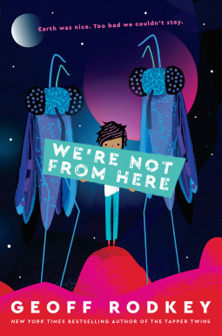

We're Not From Here
Geoff Rodkey, author.
9781524773045
The first time I heard about Planet Choom, we'd been on Mars for almost a year. But life on the Mars station was grim, so it was time to find a new home. That's how we ended up on Choom with the Zhuri. They're very smart. They also look like giant mosquitos. But that's not why it's so hard to live here. There's a lot that the Zhuri don't like: singing (just ask my sister, Ila), comedy (one joke got me sent to the principal's office), or any kind of emotion. The biggest problem, though? The Zhuri don't like us. And if humankind is going to survive, it's up to my family to change their minds. No pressure.
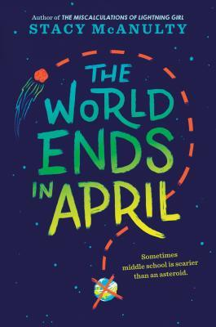

The World Ends in April
Stacy McAnulty, author.
9781524767617
When Eleanor Dross reads a Harvard scientist's prediction that an asteroid will strike Earth in April, Eleanor knows her family, with her survivalist grandfather, will be prepared. Her classmates? They're on their own! But it's hard to keep quiet about a life-destroying asteroid - especially at a crowded lunch table - and soon Eleanor is the president of the (secret) End of the World Club. It turns out that prepping for TEOTWAWKI (the End of the World as We Know It) is actually kind of fun. But you can't really prepare for everything life drops on you. And one way or another, Eleanor's world is about to change.

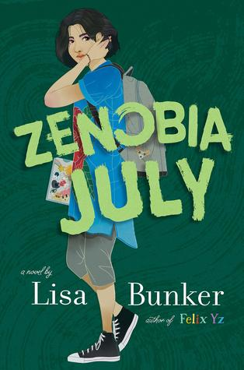

Zenobia July
Lisa Bunker, author.
9780451479402
Zenobia July used to live in Arizona with her father; now she's in Maine with her aunts. She used to spend most of her time at a computer, improving her impressive coding and hacking skills; now she's coming out of her shell and discovering a community of friends. People used to tell her she was a boy; now she's able to live openly as a girl. When someone anonymously posts hateful memes on her school's website, Zenobia knows she's the one with the abilities to solve the mystery, all while wrestling with the challenges of a new school, a new family, and coming to grips with presenting her true gender for the first time.

New and Notable Juvenile Fiction Series 2019

Awesome Dog 5000
Justin Dean
9781616208394
Marty, Ralph, and Skyler might make the ultimate secret combo when battling alien-slime ninjas in their favorite video game, but in real life they're just regular kids. That is, until the three best friends discover Awesome Dog 5000, a robotic dog with very real power-ups. Awesome Dog can "bark" a sonic boom, "walk" at speeds over three hundred miles per hour, and "fetch" with an atomic cannon. Life for Marty, Ralph, and Skyler just got a major turbo-boost! Awesome Dog 5000 is a wild action-comedy told through a mix of text and black-and-white illustrations, with a mystery to solve at the end.

The Big Idea Gang: The Worst Mascot Ever
James Preller, author.
9781328857194
Quick-thinking third-graders Lizzy, her twin, Connor, and their friends Kym and Deon have a big idea: their school desperately needs a new mascot, and they've got the perfect one in mind. Now they have to figure out a way to convince their principal and rally the rest of the school behind them. Luckily, their teacher, Miss Zips (short for Zipsokowski—but who can say that?) is skilled in the art of persuasion. Armed with Miss Zips's persuasive tips, the gang of four set out to make their claim, build a case for a new mascot, and convince Clay Elementary that Arnold the Armadillo has had his day.

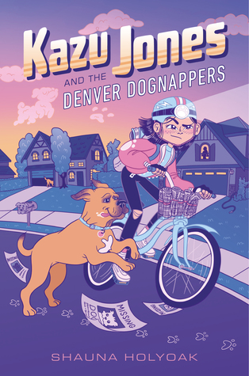

Kazu Jones and the Denver Dognappers
Shauna Holyoak, author.
9781368022408
When a string of dognappings grips her Denver neighborhood, Kazu Jones vows to track down the culprits. She can't stand to see more dogs go missing - especially once her neighbors' beloved pet is taken because of her gigantic mistake. With the help of her gang - including her best friend and expert hacker, March; and her ginormous, socially anxious pup, Genki - Kazu uncovers evidence that suggests the dognapping ring is bigger than she ever imagined. But the more she digs, the more dangerous her investigation becomes. The dognappers are getting bolder, and Genki could be next...

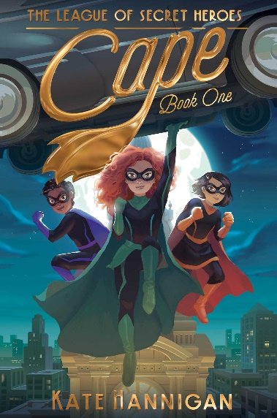

The League of Secret Heroes: Cape
Kate Hannigan, author, and Patrick Spaziante, illustrator.
9781534439115
Josie O’Malley wishes she could do more to help after her father goes off to fight the Nazis. If she can’t fly and control weather like her favorite hero, maybe she can use her math smarts to crack puzzles for the government. After an official tosses out her puzzler test because she’s a girl, an even more top-secret agency recruits Josie, along with two others: Akiko and Mae. Once they find themselves transformed into the newest superheroes in town, they learn that their skills will be crucial in thwarting a shapeshifting henchman of Hitler, and, just maybe, in solving an even larger mystery.

The Legends of Eerie-on-Sea: Malamander
Thomas Taylor, author, and Tom Booth, illustrator.
9781536207224
Violet, a fearless girl, lost her parents at the Grand Nautilus hotel when she was a baby, and she’s sure that the nervous young Herbert, Lost and Founder for the hotel, is the only one who can help her find them. The trouble is, Violet is being pursued at that moment by a strange hook-handed man. And the town legend of the Malamander - a part-fish, part-human monster - is rearing its scaly head. As various townspeople, some good-hearted, some nefarious, reveal themselves to be monster hunters on the sly, can Herbert and Violet elude them and discover what happened to Violet’s kin?

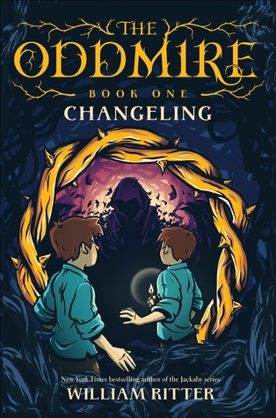

The Oddmire: Changeling
William Ritter, author.
9781616208394
Magic is fading from the Wild Wood. To renew it, goblins must perform an ancient ritual involving a newborn changeling. But when the night of the ritual arrives, the goblin Kull is distracted before he can take the human child, and the changeling is already a perfect mimic. Unable to tell them apart, both are left behind. Tinn and Cole are raised as human twins, neither knowing what secrets may be buried deep inside one of them. When a mysterious message arrives, the boys must leave their sleepy town, journeying through the Deep Dark to reach the goblin horde and uncover who they truly are.

The Oregon Trail: The Race to Chimney Rock
Jesse Wiley, author.
9781328549969
In book one of this exciting choose-your-own-trail series, it's 1850 and your first goal is to get your family, covered wagon full of supplies, and oxen to Chimney Rock on time. But hurry - you'll need to make it through the rugged mountains before winter snow hits. Plus, there are wild animals, natural disasters, unpredictable weather, fast-flowing rivers, strangers, and sickness that will be sure to stand between you and your destination! With twenty-two possible endings, which path will get you safely across the prairie and closer to Oregon City?

Rick Riordan Presents
This imprint, featuring Own Voices authors from underrepresented cultures, started in 2018, but it continues in 2019 with these new titles:
Dragon Pearl
Yoon Ha Lee, author.
9781368013352
Min, a thirteen-year-old girl with fox-magic, stows away on a battle cruiser and impersonates a cadet in order to solve the mystery of what happened to her older brother in the Thousand World Space Forces.
Sal & Gabi Break the Universe
Carlos Hernandez, author.
9781368022828
When Gabi learns that Sal is capable of conjuring things from other universes, there's only one slight problem: Their manipulation of time and space could put the entire universe at risk.
Tristan Strong Punches a Hole in the Sky
Kwame Mbalia, author.
9781368039932
Seventh-grader Tristan Strong tumbles into the MidPass and, with allies John Henry and Brer Rabbit, must entice the god Anansi to come out of hiding and seal the hole Tristan accidentally ripped in the sky.

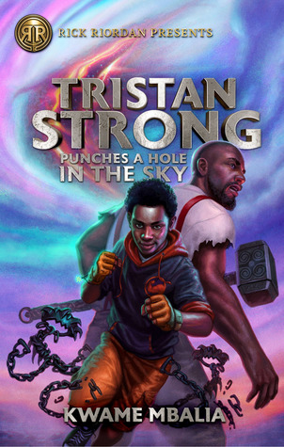

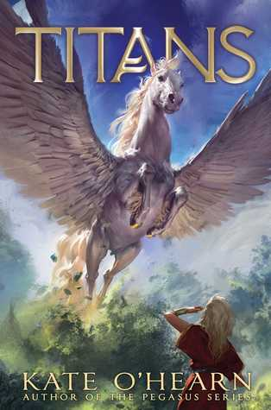

Titans
Kate O’Hearn, author.
9781534417045
Astraea is a Titan, granddaughter of Hyperion, and now a reluctant student at the brand-new school, Arcadia. At least she’s got her best friend, a winged-horse named Zephyr, to keep her company. But then they discover a human boy named Jake. How he got to Titus is a mystery to him and to them. They have to get him home before anyone else discovers him. But what the trio uncovers is something much bigger than one human boy. It’s a scheme to take down the rulers of this world, conquer it, and then do the same across the galaxy. Can a group of kids stop the invaders? Or is Titus, like Olympus before it, doomed?

We the Weirdos: Amy Price for President!
Charley Pickle, author.
9781538382042
It's the first day of middle school. Amy Price knows that's the most important day for making an impression on people. With her stutter, Amy has a hard time making friends. She has one dream, to be the class president. If only people could see her as a leader. Amy might be stuck sitting alone at lunch on the first day. That is, until she finds the Weirdo Table. They are all very different, but Amy finds friendship in this unlikely place, and, perhaps, the courage to launch her presidential campaign.

And a few series coming to a close…

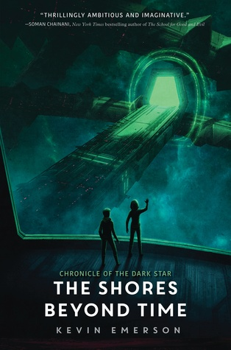

Chronicle of the Dark Star #3: The Shores Beyond Time
Kevin Emerson, author.
9780062306777
It is Earth year 2256—but the fate of the few who even remember Earth is perilously in doubt. Mina Saunders-Chang and many of the surviving humans are stranded in the Centauri system, having barely survived their confrontation with the Telphon refugees. Elsewhere, having barely made it through the battle at the Centauri system with their lives, Liam and Phoebe awake on a mysterious ship in the middle of a dead universe. The ship bears the markings of a human starliner that disappeared decades ago - but even more disturbing than that is the massive alien machine floating in the starless space before them.

Previously Released:
- Last Day on Mars (2017)
- The Oceans Between Stars (2018)

Prosper Redding #2: The Last Life of Prince Alastor
Alexandra Bracken, author.
9781484778180
Three hundred years ago, fate bound Prosper Redding and Prince Alastor of the Third Realm together. Now the human boy and fiend heir to the demon kingdom must put aside a centuries-old blood feud to save everything they love. With the fates of humans and demons at odds, the battle lines are drawn. Long ago, Prosper's ancestor Honor Redding proved that humans and demons could never be friends. But is Prosper like his ancestor? And is Alastor the same demon who was betrayed by the one human he cared for?

Previously Released:
- The Dreadful Tale of Prosper Redding (2017)

Trapped in a Video Game #5: The Final Boss
Dustin Brady, author.
9781449495732
Jesse and Eric have ten minutes to save the world. In those ten minutes, they’re supposed to dive into a massive video game universe, track down an all-powerful madman, and stop his evil plan before it’s too late. Sound impossible? It’s super impossible. There will be fire-breathing pterodactyls, angry green giants, and unicorns that shoot lasers out of their hooves. If Jesse and Eric are going to survive long enough to fight the final boss, they’ll need to rely on each other like never before. Do they have what it takes? The clock is ticking.

Previously Released:
- Trapped in a Video Game (2016)
- The Invisible Invasion (2016)
- Robots Revolt (2016)
- Return to Doom Island (201
New and Notable Juvenile Graphic Novels 2019

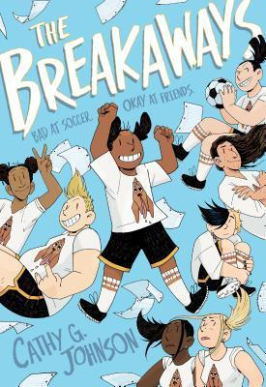

The Breakaways
Cathy G. Johnson, author.
9781250196941
Quiet, sensitive Faith starts middle school already worrying about how she will fit in. To her surprise, Amanda, a popular eighth grader, convinces her to join the school soccer team, the Bloodhounds. Having never played soccer in her life, Faith ends up on the C team, a ragtag group that’s way better at drama than at teamwork. Although they are awful at soccer, Faith and her teammates soon form a bond both on and off the soccer field that challenges their notions of loyalty, identity, friendship, and unity.

Catwad #1: It’s Me.
Jim Benton, author and illustrator.
9781338326024
From New York Times bestselling author Jim Benton, meet Catwad! He's blue, he's a bit of a grouch, and his best friend is a dim-witted cat named Blurmp who can see the bright side of anything. From pizza and computers, to love and happiness, this crabby tabby has a funny take on just about everything, and he's not afraid to share it. This collection of short comic stories will make even the grumpiest of grouches crack up and is not to be missed!

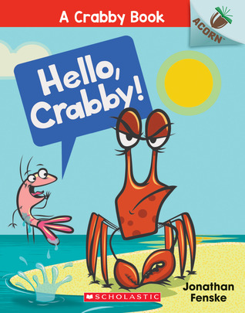

A Crabby Book #1: Hello, Crabby!
Jonathan Fenske, author and illustrator.
978-1338281507
Crabby is NOT happy. Sun is in Crabby's eyes. Salt is in Crabby's teeth. Sand is in Crabby's shell. Plankton tries again and again to cheer Crabby up -- with laugh-out-loud results! Will Crabby ever crack a smile? Or will Crabby always be crabby? With comic speech bubbles and full-color artwork throughout, Geisel Award Honoree Jonathan Fenske's early reader series is sure to be a hit with new readers! This series is part of Scholastic's early reader line, Acorn, aimed at children who are learning to read.

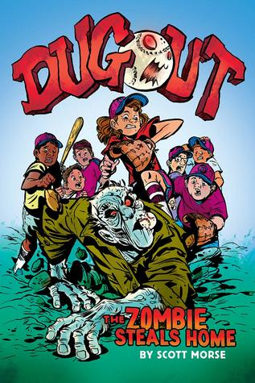

Dugout #1: The Zombie Steals Home
Scott Morse, author and illustrator.
9781338188097
Twins Stacy and Gina Cavallaro are rivals on the baseball field, each pitching for a different little league team. Gina is a sports whiz and the star of her crack team, while Stacy's band of misfits hasn't won a game all season. The battling sisters also happen to be the youngest in a long line of local witches. So when Gina's magic spins out of control and her spell accidentally raises a zombie, the girls have to set aside their differences and figure out how to set everything right. And Stacy's team of misfits - Billy, Sanchez, Levi, Beans, Paddy, Killroy, Gomez, and Boots - must band together to save the day!

Emmie & Friends #3: Just Jaime
Terri Libenson, author and illustrator.
9780062851062
The last day of seventh grade has Jaime and Maya wondering who their real friends are. Jaime knows something is off with her friend group. They’ve started to exclude her and make fun of the way she dresses and the things she likes. At least she can count on her BFF, Maya, to have her back... right? Maya feels more and more annoyed with Jaime, who seems babyish compared to the other girls in their popular group. It’s like she has nothing in common with Jai anymore. Are their days as BFFs numbered?

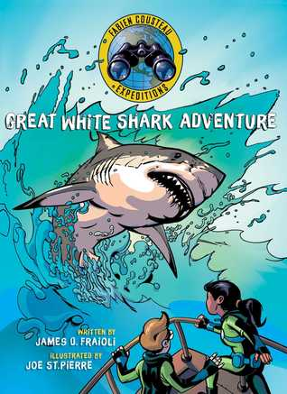

Fabien Cousteau Expeditions: Great White Shark Adventure
Fabien Cousteau and James O. Fraioli, author, and Joe St.Pierre, illustrator.
9781534420878
Junior explorers Bella and Marcus join famed explorer Fabien Cousteau and his research team as they embark on an ocean journey off the coast of South Africa, where the world’s largest concentrations of great white sharks are found. Their mission is to investigate a sighting of a massive white shark, and tag it so they can track and protect it. Along the way, they’ll encounter whales, seals, dolphins, penguins, and a colorful array of other marine life. Dramatic, graphic illustrations and a compelling story help young readers discover tons of facts about sharks and other marine creatures.
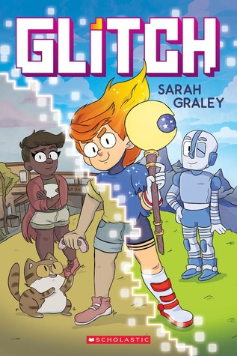

Glitch
Sarah Graley, author and illustrator.
9781338174519
Izzy has an incredible secret - she can enter the world of her new video game! She meets Rae, a robot who says Izzy is destined to save Dungeon City from the Big Boss. How is this possible?! And how can she fight for this virtual world when she's got a whole real life to keep up with? Things get even weirder when Izzy loses a life while inside the game, and she starts to worry about what might happen if she gets a Game Over for good. Meanwhile, her best friend Eric has been super upset with Izzy since she's been keeping secrets and bailing on their plans. Can Izzy survive Dungeon City and save their friendship?

Mighty Jack #3: Mighty Jack and Zita the Spacegirl
Ben Hatke, author.
9781250191731
Jack and Lilly are no strangers to heroics. So when they meet Zita the Spacegirl, fresh from her interplanetary travels and seeking their help to face a new threat, they’re more than ready for another adventure. But the danger growing just outside the door to their world is greater than anything the new friends could have imagined. An army of giants and screeds stands ready to lay siege to Earth, determined to put the age of humans to an end. With the gate between worlds growing weaker and time running out, can the heroes come together to save their world from their greatest enemy yet?

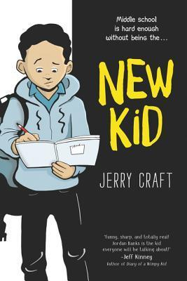

New Kid
Jerry Craft, author and illustrator.
9780062691194
Seventh grader Jordan Banks loves nothing more than drawing cartoons about his life. But instead of sending him to the art school of his dreams, his parents enroll him in a prestigious private school known for its academics, where Jordan is one of the few kids of color in his entire grade. As he makes the daily trip from his Washington Heights apartment to the upscale Riverdale Academy Day School, Jordan soon finds himself torn between two worlds - and not really fitting into either one. Can Jordan learn to navigate his new school culture while keeping his neighborhood friends and staying true to himself?
The Okay Witch
Emma Steinkellner, author and illustrator.
9781534431454
Thirteen-year-old Moth Hush loves all things witchy. When some eighth-grade bullies try to ruin her Halloween, something really strange happens. It turns out that Founder’s Bluff, Massachusetts, has a centuries-old history of witch drama. And, surprise: Moth’s family is at the center of it all! When Moth’s new powers show up, things get totally out-of-control. She meets a talking cat, falls into an enchanted diary, and unlocks a hidden witch world. Secrets surface from generations past as Moth unravels the complicated legacy at the heart of her town, her family, and herself.

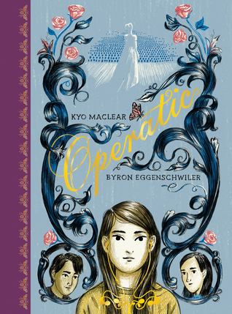

Operatic
Kyo Maclear, author, and Byron Eggenschwiler, illustrator.
9781554989720
It’s almost the end of middle school. Charlie has to find her perfect song for a music class assignment, but it’s hard for Charlie to concentrate when she can’t stop noticing her classmate Emile, or wondering about Luka, who hasn’t been to school in weeks. Then, the class learns about opera, and Charlie discovers the music of Maria Callas. The more she learns about Maria’s life, the more Charlie admires her passion for singing and her ability to express herself fully through her music. Can Charlie follow the example of the ultimate diva, Maria Callas, when it comes to her own life?

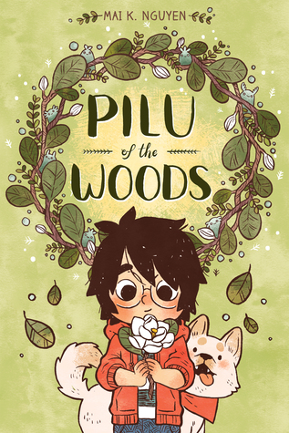

Pilu of the Woods
Mai K. Nguyen, author and illustrator.
9781620105511
When her emotions get the better of Willow one day, she decides to run away into the woods. There, she meets Pilu, a lost tree spirit who can’t find her way back home - which turns out to be the magnolia grove Willow’s mom used to take her to. Willow offers to help Pilu, and the two quickly become friends. But the journey is long, and Pilu isn’t sure she’s ready to return home yet. As a storm rages and Willow’s emotions bubble to the surface, they suddenly take on a physical form, putting both girls in danger… and forcing Willow to confront her inner feelings once and for all.

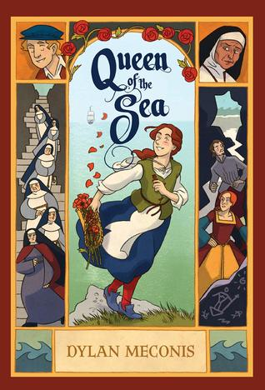

Queen of the Sea
Dylan Meconis, author and illustrator.
9781536204988
Margaret has lived on the Island, with the sisters of the Elysian order, for as long as she can remember, and she loves every inch of it. But everything changes with the arrival of Eleanor, the former queen of Albion, banished to the Island by the half sister who has stolen her throne. As Margaret grows closer to Eleanor, she grapples with the revelation of the island’s sinister true purpose, as well as the truth of her own past. Faced with a perilous choice, Margaret will have to decide who she wants to be in this fictionalized history of a quiet, windswept island at the heart of a treasonous royal plot.

Red Panda & Moon Bear
Jarod Rosello, author.
9781603094443
Red Panda and Moon Bear are the defenders of their community! Together, these brave siblings rescue lost cats, scold bullies, and solve mysteries, all before Mami and Papi get home. But lately... the mysteries have been EXTRA mysterious. All of RP and MB's powers may not be enough to handle spooks, supervillains, alien invaders, and time warps! It'll take all their imagination - and some new friends - to uncover the secret cause behind all these events before the whole world goes crazy.

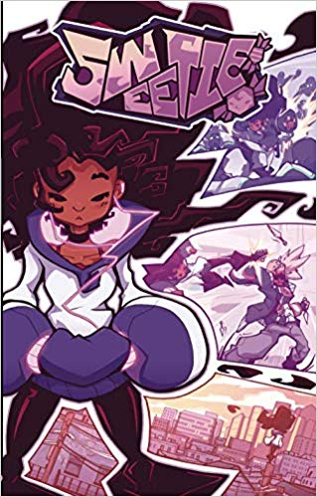

Sweetie
Sean Dillon, author and illustrator, and Steven Petrivelli, author.
9781632294746
Maggie isn’t your typical comic book, cartoon, and action movie fangirl. Through keen observation and unbending determination, she’s taught herself all the death-defying stunts and fighting styles of her favorite action stars and superheroes! But superheroes and evil villains are all kid stuff... right? Wrong! On the eve of her first day of high school, Maggie has a run-in with an evil mercenary group known as the Numbers. After years of training, it’s up to Maggie to be the self-taught superhero the city needs! But is she truly ready for the responsibility that comes with the title of “hero”?

